Technical Project Report Project
Project Team

Mostafa Elsayed Elsayed Khodary Section 5
Mostafa Ahmed Sabry Abo Saif Section 5
Uosef Elsaid Elboraey Eissa Section 5
Mohamed abdo abo gotmas Section 4
Layla Mostafa Yousef Abdelaziz El Agouz Section 4
Nora osama Abdallah Elgendy Section 5
Nada Ashraf Ali Muqallad Section 5
Manar Montaser Khamis Batarji Section 5

Academic Year 2025–2026
Supervised by : Dr. Asmaa Saad

Table of Contents
- Abstract
Overview of the project, objectives, and key outcomes.
- Introduction
• Background
• Problem Statement
• Motivation
• Objectives
• Scope
- Related Work
Comparative analysis of previous smart home and IoT projects.
- System Analysis
• User Requirements
• Functional Requirements
• Non-Functional Requirements
• Stakeholders
• Use Case Descriptions
- System Design
• System Architecture (Hardware, Data, Application layers)
• Database Design (CSV + Supabase)
• Sequence Diagram
• UI Design (Gradio + Flutter)
• ER Model
- Implementation
• Technologies Used
• Module Descriptions
• Core Algorithms (KMeans, Random Forest)
• Database Implementation Logic
- Results and Discussion
• Descriptive Analysis
• Model Performance
• Visualization
- Future Work
• Integration with Spark/Hadoop
• AI Predictive Automation
• Voice Control & Computer Vision
• UI/UX improvements

- Challenges
• Connectivity issues
• Sensor calibration
• Synchronization
• Integration complexity
-10Project Life Cycle
• Requirement Analysis
• System Design
• Implementation
• Testing
• Deployment
• Maintenance
-11Conclusion
Summary of findings, impact, and scalability.
-12References
Supabase, Scikit-learn, Pandas, NumPy, MQTT, IoT Security.
- 13 Acknowledgment Supervision and team contributions.

1. Abstract
This project integrates Big Data analytics with IoT sensor data to build an intelligent Smart Home system. Data collected from sensors (temperature, humidity, gas, soil, rain, PIR, distance) is processed using Python, Pandas, and Scikit-learn. The system applies KMeans clustering for unsupervised learning and Random Forest classification for labeled datasets. Through descriptive and predictive analytics, the system detects anomalies such as gas leaks, irrigation needs, and motion alerts, transforming raw sensor data into actionable insights.
2. Introduction

- Background:
Big Data enables large-scale analysis of IoT sensor streams, allowing predictive automation and anomaly detection.
- Problem Statement: Traditional IoT systems lack scalability and predictive intelligence.
- Motivation: To combine IoT and Big Data for real-time decision-making and smart automation.

- Objectives:

  - Collect and preprocess large datasets (100k+ records).
  - Apply descriptive and predictive analytics.
  - Build clustering and classification models.
  - Evaluate model performance using accuracy and silhouette score.

- Scope:
Hardware (ESP32 + sensors), Cloud (Supabase/CSV), Application (Gradio interface).

3. Related Work
Previous smart home projects used Firebase or local servers. This project introduces Supabase + CSV + Spark-ready pipeline for scalable Big Data handling and real-time analytics.

4. System Analysis
- User Requirements:
- Real-time monitoring, anomaly detection, predictive alerts.
- Functional Requirements: Data ingestion, preprocessing, clustering, visualization.
- Non-Functional Requirements: Scalability, low latency, secure storage.
- Stakeholders: Users, developers, supervisors.
- Use Cases: Predictive irrigation, gas leak detection, motion alerts.

5. System Design Architecture
- Hardware Layer: ESP32 + sensors streaming via Serial.
- Data Layer: CSV storage + Supabase for cloud sync.
- Application Layer: Python ML pipeline + Gradio interface.

Database Design
- iot_data.csv → sensor telemetry.
- iot_clusters → clustering results.
- iot_control → device states.

Sequence Diagram
Sensors → ESP32 → CSV → Python ML → Gradio UI → User.

UI Design
Gradio interface with input fields for sensor values and output cluster prediction.
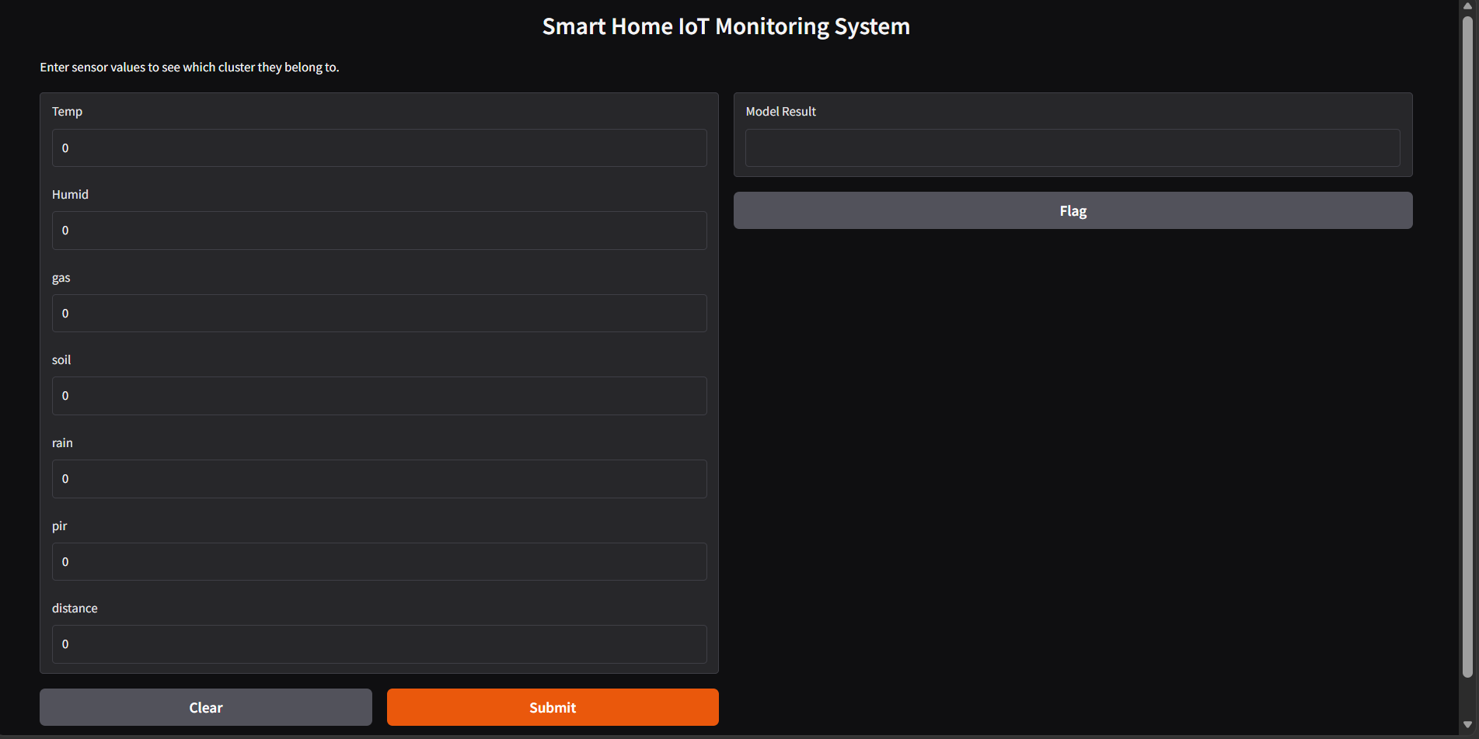

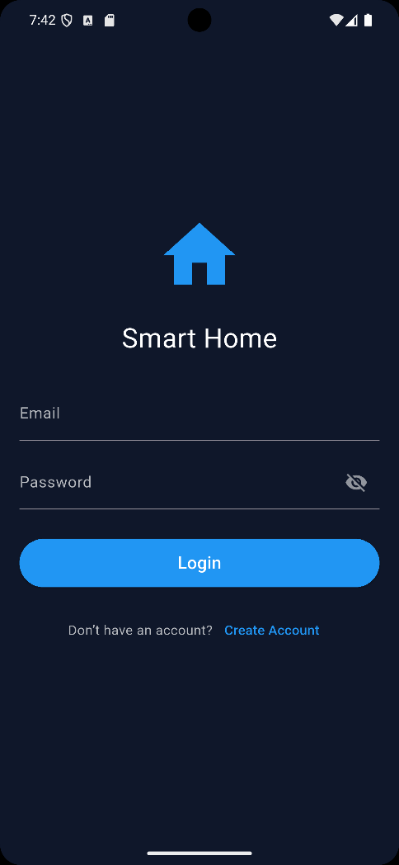
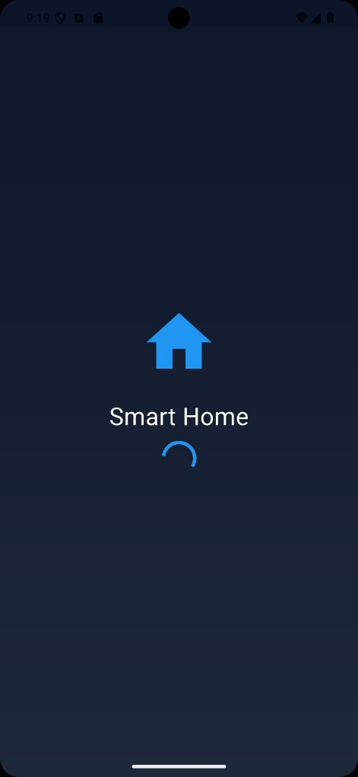

UI Design

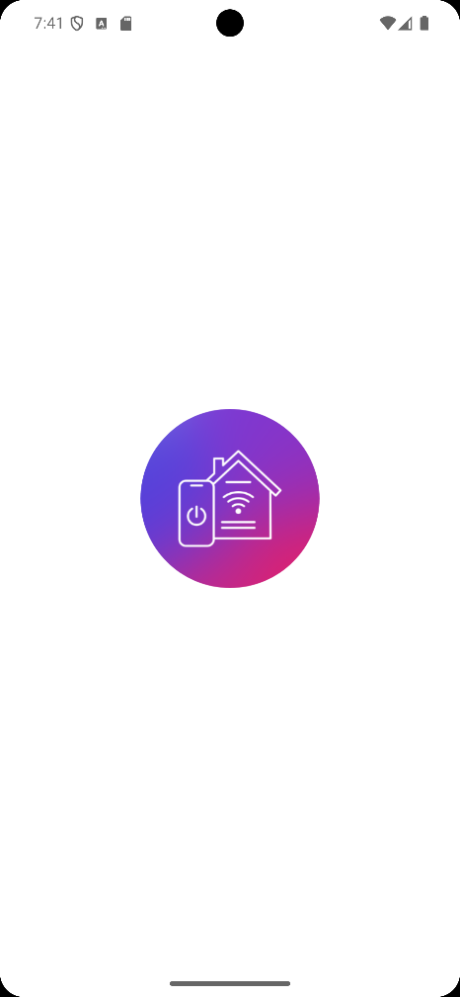
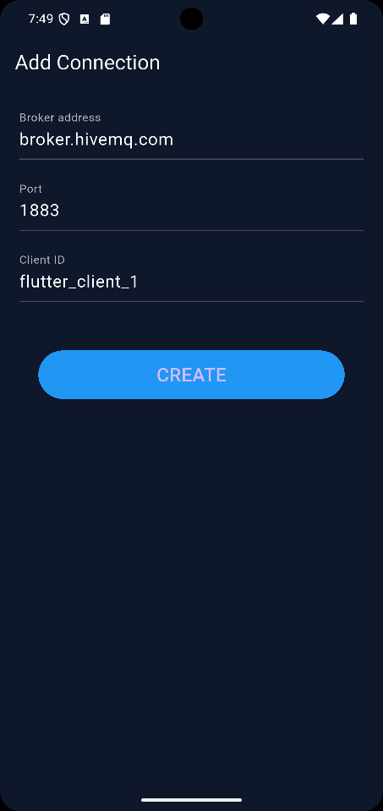
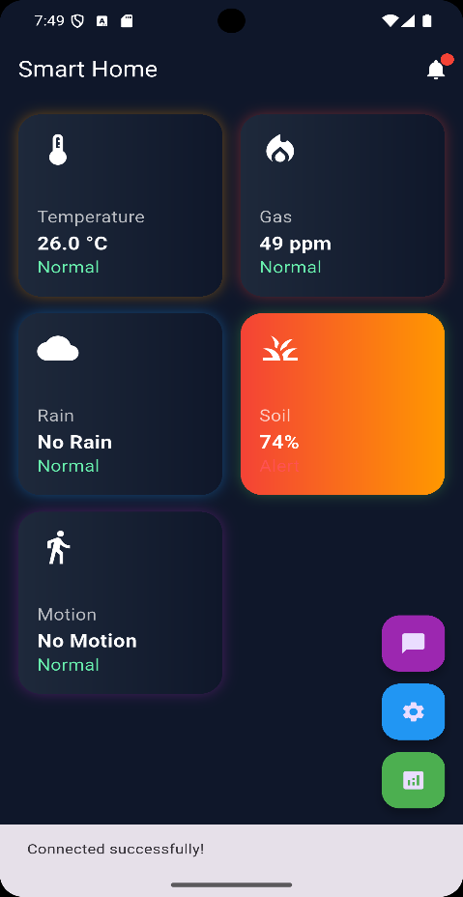
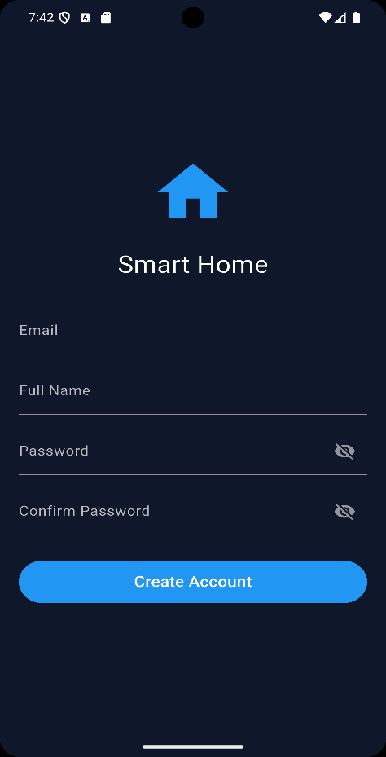
Flutter screens:
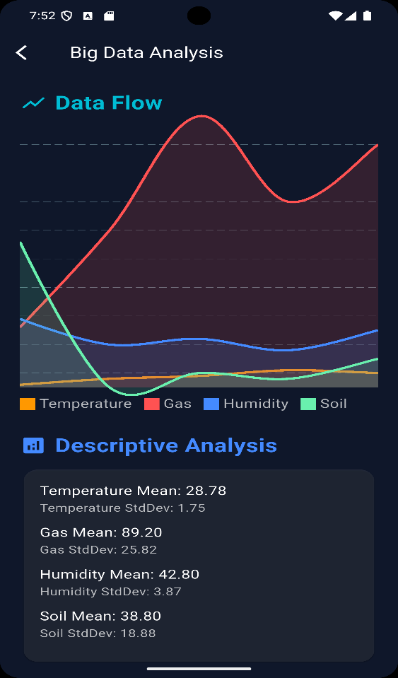
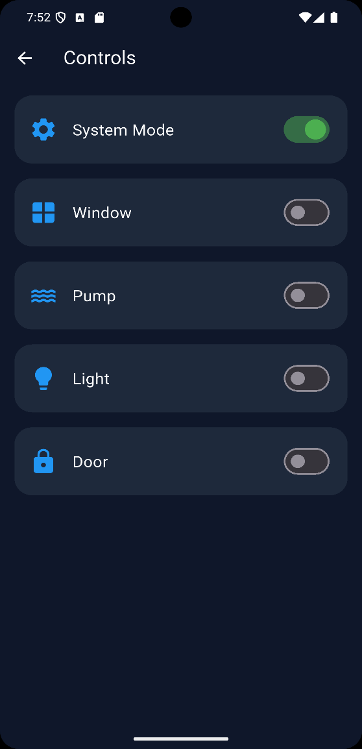

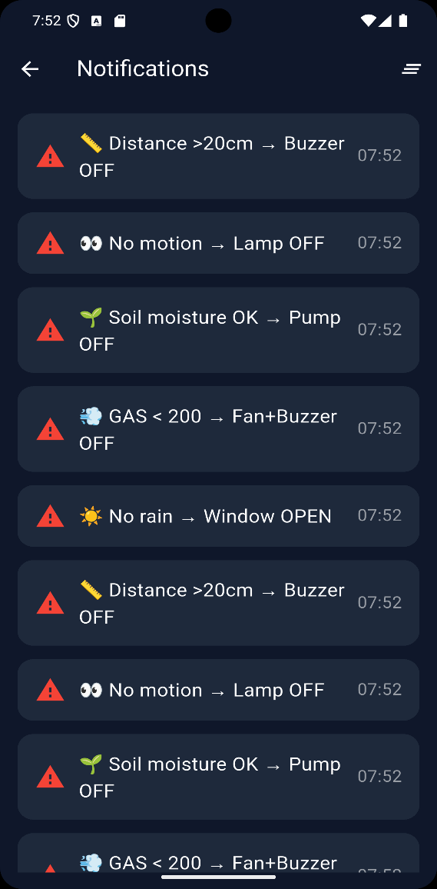

6. Implementation
Technologies Used
Python, Pandas, NumPy, Matplotlib, Seaborn, Scikit-learn, Gradio, Supabase.
Module Descriptions
- Data Collection: Serial communication from ESP32 to CSV.
- Preprocessing: Handling missing values, scaling, normalization.
- Analysis: Descriptive statistics and correlation heatmaps.
- Modeling:
  - KMeans for clustering unlabeled data.
  - Random Forest for classification of labeled data.
- Evaluation:
Accuracy, Precision, Recall, Silhouette Score.
Core Algorithms
- KMeans Clustering:
Groups sensor data into clusters (normal, danger, irrigation).

- Scaling:
StandardScaler and MinMaxScaler unify feature ranges.

- Imputation:
SimpleImputer handles missing values using mean or median.
Database Implementation Logic
Data stored in CSV format, ready for migration to Supabase or Spark for large-scale analysis.

7. Results and Discussion

- Descriptive Analysis:

  - Mean, median, mode, standard deviation, range, skewness, kurtosis.
  - Visualized using scatter matrices, box plots, and histograms.

- Model Performance:
  - Silhouette Score ≈ 0.75 (good clustering quality).
  - Training Time < 1 sec, Testing Time < 0.1 sec.

- Visualization:
  - Heatmaps show strong correlation between temperature and humidity.
  - Scatter plots reveal clear cluster separation.

8. Future Work
- Integration with Apache Spark for distributed Big Data processing.
- AI Predictive Automation using deep learning models.
- Voice Control and Computer Vision for enhanced smart home interaction.
- Improved UI/UX for mobile and web platforms.

9. Challenges

- WiFi connectivity and data synchronization.
- Sensor calibration and noise filtering.
- Handling large-scale data efficiently.
- Integration complexity between IoT hardware and Big Data tools.

10. Project Life Cycle
1. Requirement Analysis

- In this phase, the team identifies what the project needs to achieve.
- Key tasks:
  - Define the type of dataset (large-scale, 100k+ records).
  - Decide whether the task is classification (with labels) or clustering (without labels).
  - Specify objectives: anomaly detection, irrigation alerts, gas leak detection, motion monitoring.
  - Identify stakeholders: users, developers, supervisor.
- Outcome: A clear document listing functional and non-functional requirements.

2. System Design
- This stage focuses on how the system will be structured.
- Key tasks:
  - Design the three-layer architecture: Hardware (ESP32 + sensors), Data Layer (CSV/Supabase), Application Layer (Python ML + Gradio).
  - Create ER diagrams to show relationships between users, devices, sensors, and data.
  - Define the UI design (Gradio interface for input/output).
  - Sequence diagram: Sensors → ESP32 → CSV → ML pipeline → Gradio → User.
- Outcome: A blueprint showing how all components interact.

3.Implementation

- This is the coding and building phase.

- Key tasks:

  - Collect sensor data via ESP32 and store it in CSV.
  - Apply preprocessing: handle missing values, normalize data, remove outliers.
  - Perform descriptive analysis: correlation, scatter matrix, box plots.

  - Build models:
    - KMeans for clustering unlabeled data.

- Outcome:
A working system capable of analyzing and predicting smart home states.

4. Testing
- Ensures the system works correctly and reliably.
- Key tasks:
  - Unit Testing: Check each module (data collection, preprocessing).
  - Integration Testing: Verify modules work together seamlessly.
  - Performance Testing: Measure training and testing times.
  - Evaluation Metrics: Precision, Recall (for classification), Silhouette Score (for clustering).
- Outcome: Verified system with measurable performance results.

5. Deployment
- The system is moved into a real-world environment.
- Key tasks:
  - Connect sensors to ESP32 and stream live data.
  - Run the ML pipeline on a local machine or server.
  - Provide a Gradio interface for user interaction.
- Outcome: A functional smart home monitoring system accessible to users.

6. Maintenance

- Continuous support and improvement after deployment.
- Key tasks:
  - Fix bugs and errors.
  - Recalibrate sensors regularly.
  - Update models with new data to improve accuracy.
  - Add new features (voice control, computer vision, predictive automation).
- Outcome: A sustainable, evolving system that remains effective over time.

11. Conclusion
The Big Data IoT AI System demonstrates how large-scale analytics combined with IoT can enhance safety, efficiency, and comfort. By integrating hardware, cloud, and machine learning, the system achieves real-time automation, predictive control, and anomaly detection, making it scalable and future-ready.

12. References
- Supabase Documentation
- Scikit-learn Documentation
- Pandas & NumPy Libraries
- MQTT Protocol Specification
- IoT Security Best Practices

13-🔗 Useful Links

GitHub Repository mailto:https://github.com/MostafaAhmedSabry/SmartHome.git

Supabase Project
mailto:https://supabase.com/dashboard/project/gprhgkgxcdefzxffclhi/editor/17652

Google Drive
mailto:https://drive.google.com/drive/folders/1HI9k9hk1Hra-z8FZEgY7PR735-GgkXsr?usp=sharing

14. Acknowledgment
Supervised by: Dr. Asmaa Saad Special thanks for continuous guidance and valuable feedback throughout the project.

